Internet of Things using Node-Red and Alexa

Anoja Rajalakshmi, Hamid Shahnasser

School of Engineering

San Francisco State University

San Francisco, California

arajalak@mail.sfsu.edu

*Abstract*— The Internet of Things (IoT) means learning and interacting with millions of things including services, sensors, actuators, and many other objects on the Internet. This project enhances on how far IoT can connect devices on different platforms. This will effortlessly help humans in various fields like Home automation, networking, data monitoring and others. The evolution of human-machine user interface has drastically changed over the years. The path of advancement has been through keyboard, mouse, touch and now it is Voice. This new user interface can be achieved by Alexa Voice Service. Currently, we have very few devices that can be controlled using Alexa. Some of the examples are Philips Hue, WeMo, and Wink. But these are limited to certain hardware. The initial installation and maintenance is expensive. The proposed system connects and controls most of the IoT devices connected to it using Voice.

As the number of devices on the cloud increase, there is need for updating firmware more frequently. This is tedious. It involves taking out the installed devices, changing the code and flashing it again. To overcome these, processing of data and response can be done elsewhere. Node-Red, a visual wiring tool helps in connecting devices with ease resulting in effortless and rapid connection setups.

*Index Terms*—Node-Red, IoT, Raspberry Pi, MQTT, Wi-Fi, Arduino, AWS, Node-MCU, ESP8266, ESP32, Intel Edison, Alexa.

# Introduction

In the early 90s, the word internet was used to express the technology of connecting computers all over the world using wired or wireless links. Since then the internet has been effectively used for file sharing, web browsing, social media, and so on. However, recent development and deployment of smart technologies require the need for objects to be ubiquitously connected in the cloud [1]. Consequently, this demands the need for more sophisticated technologies to support a new communication called machine-to-machine (M2M) [2]. The benefits of M2M communication is numerous: It makes it more operational, improves quality, decision-making and is environmental by monitoring and controlling over businesses from any part of the world.

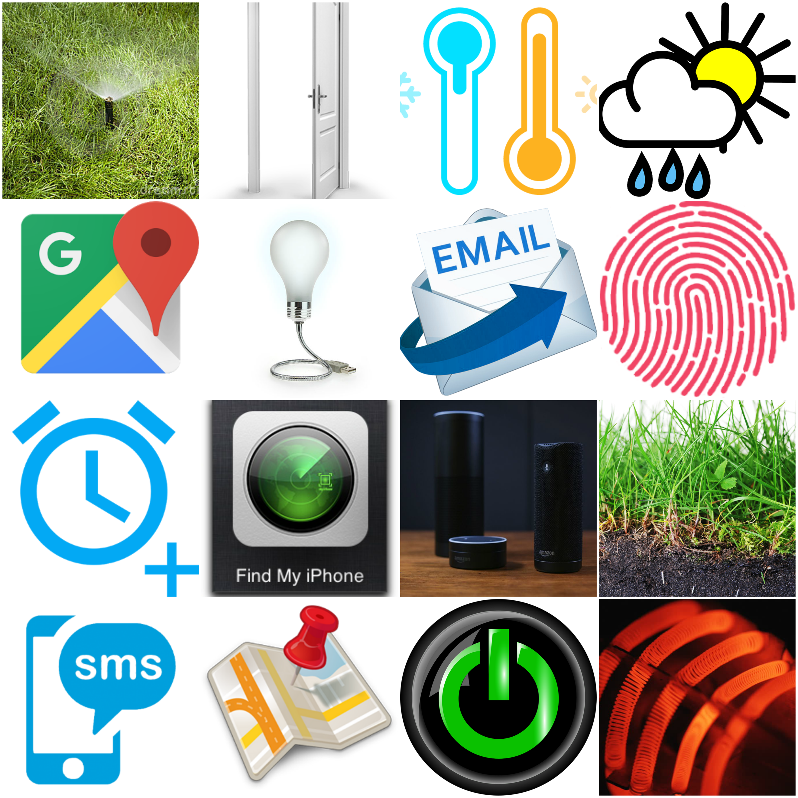

Fig. 1. Project at a glance

Technology has brought intelligence and smart devices to the market. Human life style is changing by taking advantage if these new technologies in home automation and smart communities which IoT allows development effect [3][4]. Moreover, IoT applications support variety of daily activities such as route planning, navigation, transportation decisions, traffic, environment and healthcare monitoring [5-7].

Number of smart appliances with Wi-Fi and 3G/4G functionality that can be controlled remotely are increasing. IoT allows these devices connected and controlled remotely [8][9]. A very recent survey by CISCO predicts that by 2021 there will be an 8.3 billion handheld devices and 3.3 billion M2M connections like tracking devices, health, and manufacturing sectors [10].

Amazon Web Services (AWS) provide an inexpensive online cloud computing services. AWS helps in creating several Message Queue Telemetry Transport (MQTT) brokers which are the base for M2M connections [11]. AWS provides a scalable and extensible infrastructure for cloud IoT. They interact with both virtual and physical hardware [12]. Thus AWS is found to be one of the most cost efficient cloud services [13].

# PROPOSED SYSTEM

In this project, a cost-effective system is developed that use minimal power and can handle diverse sites as houses, industries and other public places. As shown in Fig. 1, all the components are connected together to the cloud. The Data reaches cloud and the response is immediate. The user can set preferences according to their need. This flexibility is not available in the existing systems.

The system uses Raspberry Pi 3 Model along with Intel Edison board for sensor inputs and the interaction with the local server created by Node-Red. There are other miniature boards like ESP8266 and ESP32 which are connected to sensors and actuators. These boards are placed in locations with Wi-Fi accessibility. All the sensor inputs reach the cloud using a protocol called MQTT.

# HARDWARE COMPONENTS

IoT devices are predestined to be of two types: Devices that ACT on inputs such as motors, light bulbs, and robots; and Devices that SENSE inputs such as temperature sensors and light sensors.

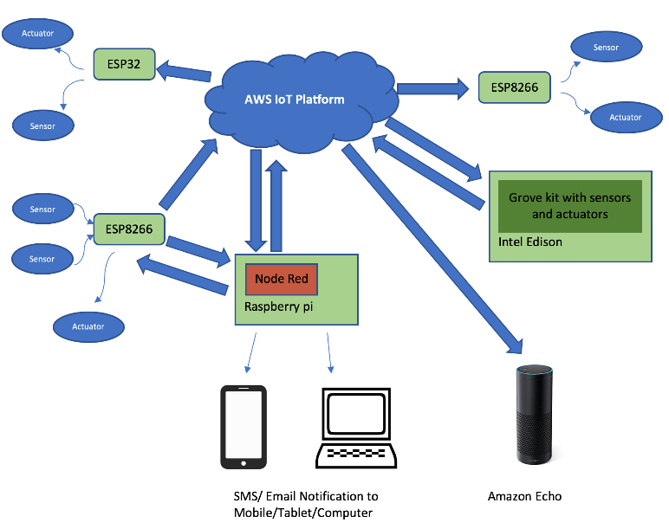

Fig. 2. Block Diagram

This system customs various hardware platforms like Raspberry Pi, Intel Edison, and Arduino versions: ESP8266 and ESP32. Data flows to and from the IoT Platform as shown in Fig 2. Node-Red will be installed in Raspberry Pi which uses MQTT that communicates with arduino peer devices. ESP8266 and ESP32 chips are relatively inexpensive wireless devices capable of transmitting sensor information through Wi-Fi. Listed below is the description of the Hardware components used in this project.

* 1. *Raspberry Pi*

Raspberry Pi is a microcomputer with complex computational capabilities [14]. It runs in Linux platform. Node-Red, a programming tool, is installed in Raspberry Pi. Node-Red allows direct accessing of GPIO pins of Raspberry Pi and this data can be sent directly to the cloud.

* 1. *Intel Edison*

Edison is a small computing platform which is inexpensive and product-ready system [15]. With the help of Grove kit, multiple sensor inputs and actuators can be programmed and connected to the cloud.

* 1. *ESP8266*

The ESP8266 Wi-Fi Module is a low-cost SOC that can be easily connected to the cloud. This break-through chip is trending in the market. This project makes use of the multiple Node-MCU which is a development board for ESP8266.

* 1. *ESP32*

The ESP32 has hybrid Bluetooth and Wi-Fi with low power consumption. This robust chip is resilient to industrial environments.

# AWS COMPONENTS

Amazon Web Services (AWS) provides a wide variety of products which are cloud-based, such as compute, analytics, IoT, security, and storage. In this project, the following products of AWS are being used.

1. *AWS IoT*

AWS IoT is a platform that enables connected devices to securely communicate and relay information to and from the AWS platform using MQTT.

1. *AWS Lambda*

A Lambda function is a state-less piece of code, with an input and an output that can be triggered from a wide array sources internal and external to AWS. As shown in Fig. 3 Lambda triggers the IoT device by listening to the voice commands of the user.

1. *AWS EC2*

Elastic Compute Cloud (EC2) is a simple web service that helps run virtual machines in the cloud. Its reliable and controllable. As its name says, it enables us to resize capacity within minutes.

1. *Alexa Skill*

Alexa is an Amazon’s Voice Service which allows customized skills, connect IoT devices and publish them. To create an Alexa Skill, A lambda function is used. The “*things*” that are registered in AWS IoT is being linked to the Lambda. Fig. 3 shows a user controlling a physical device using Alexa. As an example, three different devices are connected- a light bulb, a heater and a garage door.

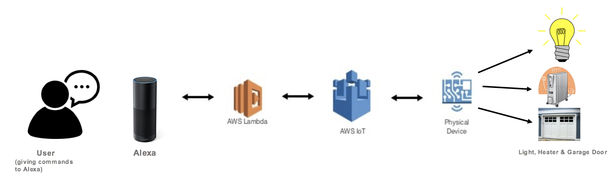

Fig. 3. Alexa Flow Diagram

# NODE-RED COMPONENTS

Node-Red, developed by IBM helps in combining the hardware, API and other online services in a smart way. It is a flow editor based on the browser. It can be installed in a Linux Platform. It comprises of two components as explained below.

*A. Nodes*

Nodes are written in node.js. It can be easily installed from the Node-Red library.

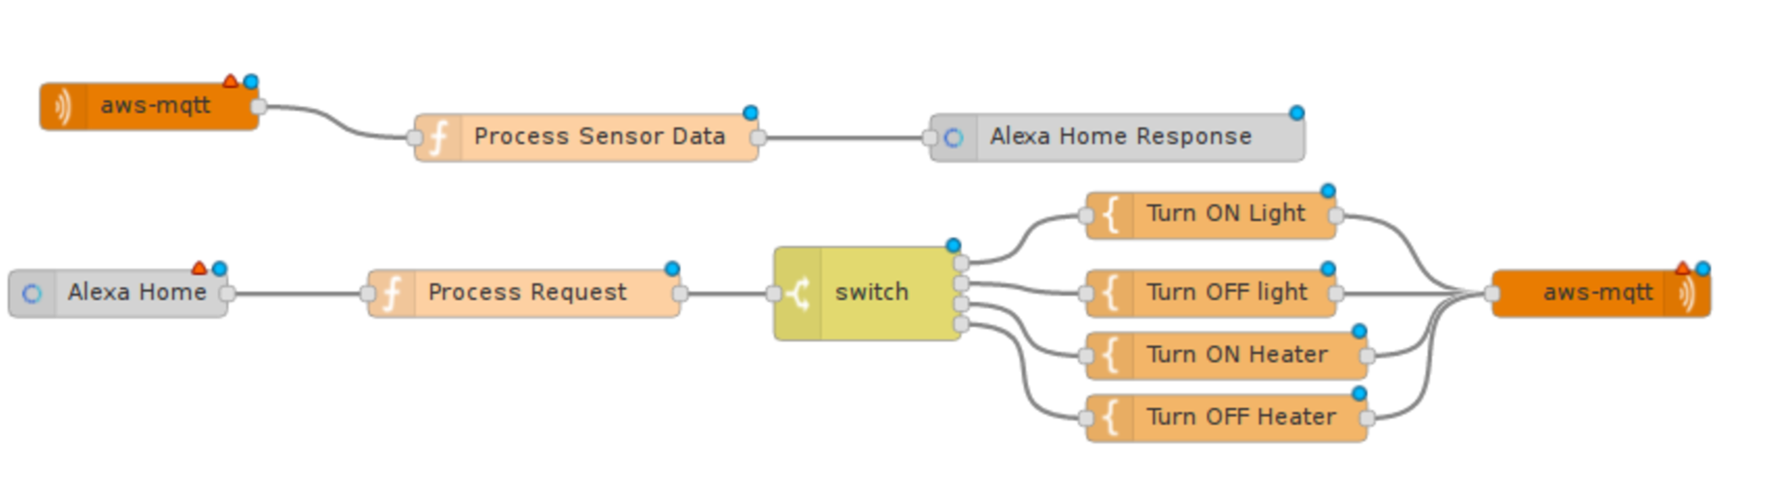 Fig. 6. Node-Red: AWS and Alexa

*B. Flows*

Node-Red Flow Diagrams are created by integrating various Nodes that are configured and are stored using JSON.

# IMPLEMENTATION SETUP

Node-Red provides ease for connections by just drawing wires or links and adding parameters to them. The flow diagrams are self-explanatory. Each node has inputs which are msg.payload written in javascript. Double clicking on a node opens up a space for inclusion of the code.

Consider a scenario as an application for the above. A Light sensor talks to a light bulb, based on the intensity of light, Bulb gets turned ON or OFF. Fig. 4 is the basic MQTT connection that subscribes to a topic from the Light sensor and publishes a message on to the Light ON/OFF topic.

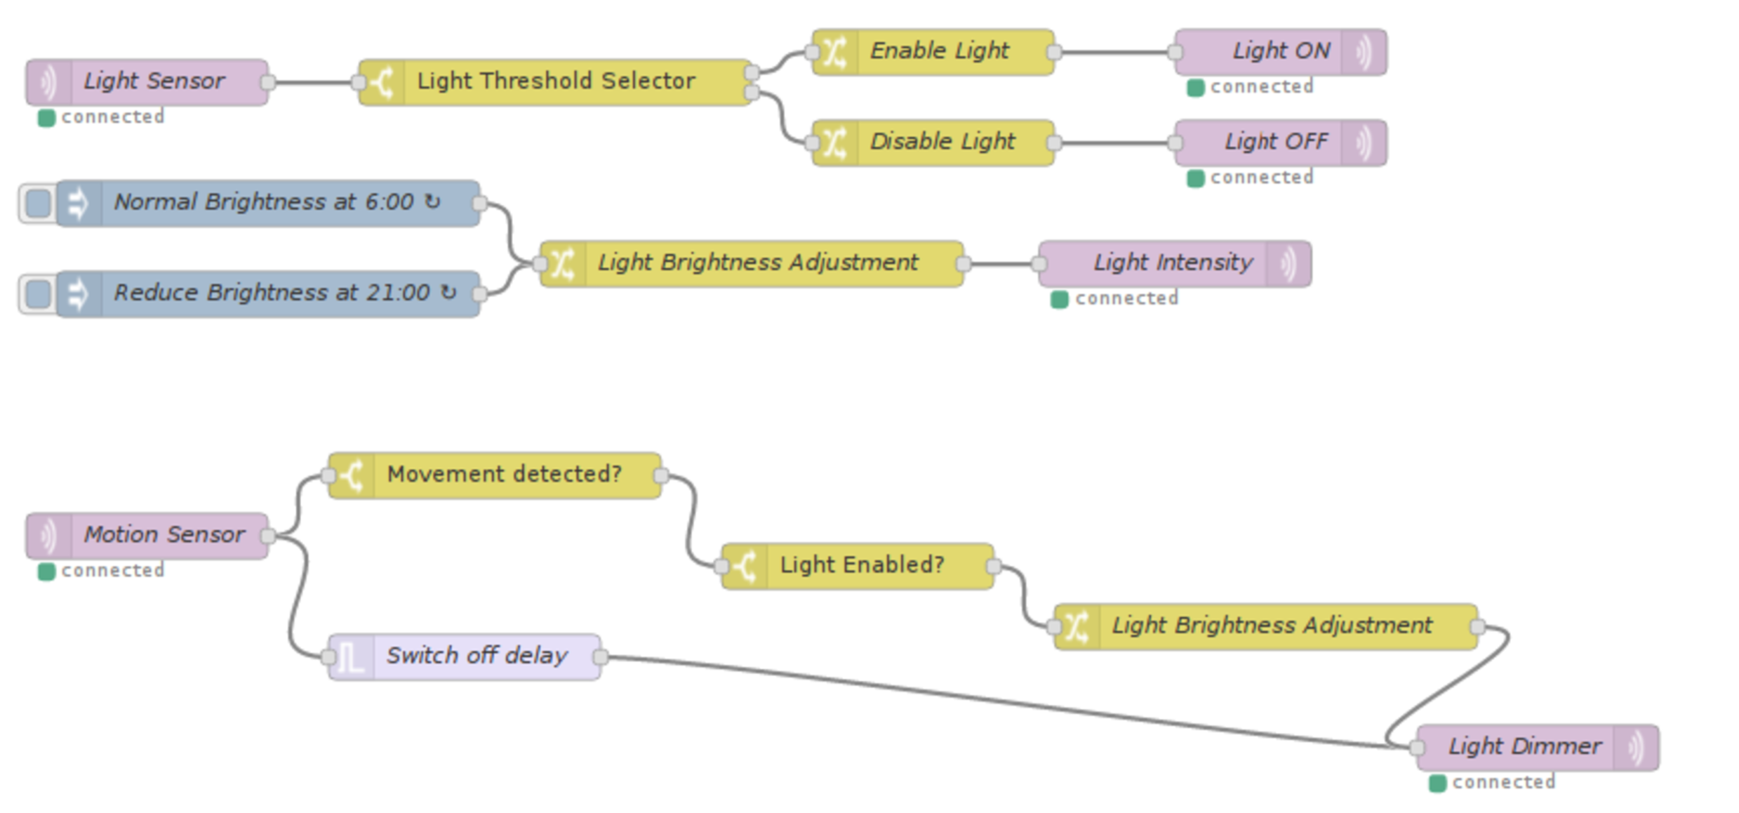

Fig. 4. Node-Red: MQTT communication with Hardware

The following scenario illustrates auto monitoring of the iphone location and battery status of the user, every 30 minutes as shown in Fig. 5. As mentioned, the response to the data processing can be easily changed by double-clicking on the node and editing it or altering node connections.

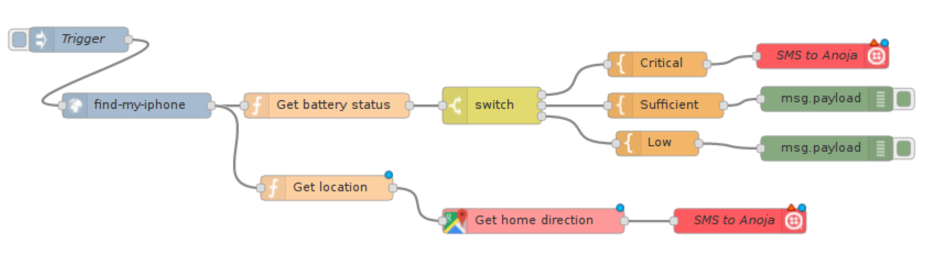

Fig. 5. Node-Red: iPhone Monitoring

Consider a further scenario in a house where the user needs to control various home equipment like Heater, Fan, and Light just with his Voice. In Fig. 6, AWS IoT devices in cloud sends its sensor input through MQTT into Node-Red. The function “Process Sensor Data” can be edited according to the user preferences. The “Alexa Home” node request is processed and transformed to response format like Turn ON/OFF light or heater. New additions can be done in this flow when an IoT Device gets added in AWS IoT.

The subsequent scenarios have been implemented to access an external web server that provides weather. This helps the user to get unfavorable weather conditions whenever necessary as stated in Fig. 7.

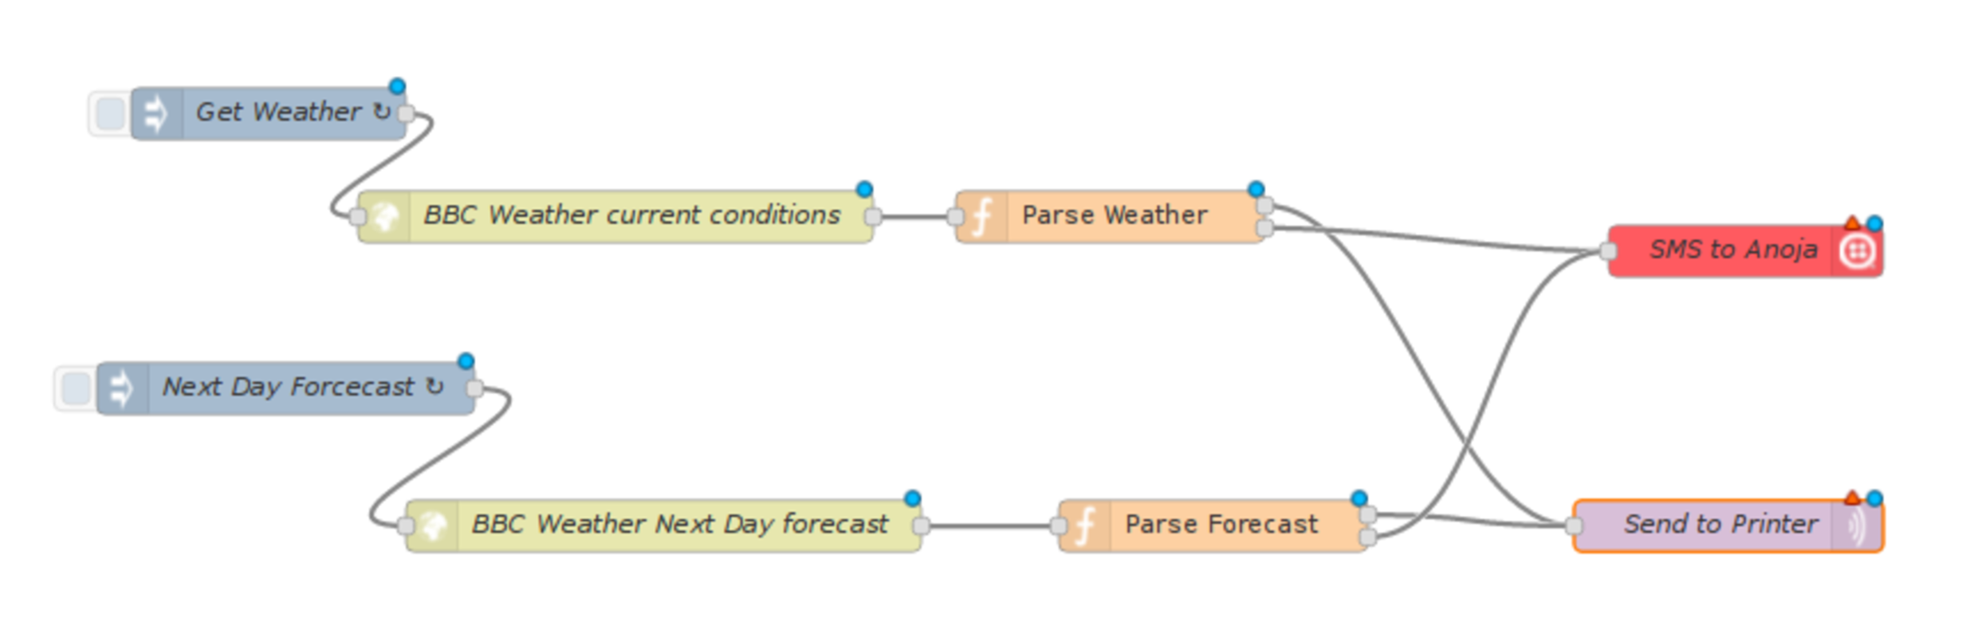Fig. 7. Node-Red: Weather Forecasting

The Fig. 8 clarifies how Intrusion check is enabled. The ultrasonic sensor is connected to the GPIO Pin 5 of Raspberry Pin. This pin level is detected on a periodical basis and the presence of a thing is alerted to the user through email.

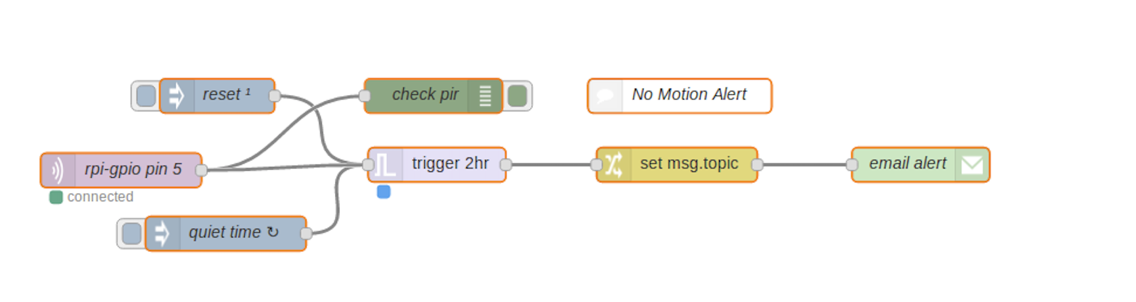 Fig. 8. Node-Red: Intrusion Check

# CONCLUSION

These days smart devices are found everywhere. Having a control them is easy, but linking them with each other is a difficult task. This work provides a solution for this scenario by providing a flexible platform that controls all IoT devices on cloud. This project provides the elasticity of altering the process of responding to an event. As an example, it permits the user change a notification from sending an email to SMS or turning off light to reduce the brightness and much more. With the help of Node-Red, this task is made easy. Currently, Node-Red runs on the local machine, like in Raspberry Pi or a Linux machine. As an extension of this project, Node-Red can be brought into the cloud with the help of IBM Bluemix platform.

Alexa provides a better way of communication with the IoT devices and the users. The Internet of things will connect various hardware devices installed in homes, industries and other sophisticated places which the users can control. These devices can also control each other. This will be the future of technology.

# ACKNOWLEDGEMENT

This work was partially funded by the IRA Research Awards by the Office of Academic Honours and Scholarships at San Francisco State University.

# References

1. Khan, R., Khan, S. U., Zaheer, R., and Khan, S., "Future internet: The Internet of Things architecture, Possible applications and key challenges," IEEE 10th International Conference on Frontiers of Information Technology, 2012, pp. 257 – 260.
2. Andreev, S., Galinina, O., Pyattaev, A., Gerasimenko, M., Tirronen, T., Torsner, J., Sachs.J., Dohler, M., and Koucheryavy, Y., "Understanding the IoT connectivity landscape – A Contemporary M2M Radio technology roadmap," Communications Magazine, vol.53 no.9, 2015, pp. 32 – 40.
3. Zhao, K., and Ge, L., "A Survey on the Internet of Things security," Ninth International Conference on Computational Intelligence and Security, IEEE, 2013, pp. 663 – 667.
4. J. Gubbi, R. Buyya, S. Marusic, and M. Palaniswami, "Internet of things (IoT): A vision, architectural elements, and future directions," Future Generation Computer Systems, vol. 29, no. 7, pp. 1645–1660, 2013.
5. Almobaideen, W., Allan, M., and Saadeh, M., "Smart Archaeological Tourism: Contention, convenience and accessibility in the context of

cloud-centric IoT", Mediterranean Archaeology and Archaeometry, vol.16, no.1, 2016, pp.227-236.

1. Almobaideen, W., Saadeh, M., Al-Anbaki, N., Zaghloul, R., and Aladwan, A., "Geographical route selection based on user public transportation and service preferences," 9th International Conference on Next Generation Mobile Apps, Services and Technologies (NGMAST), Cambridge, 2015. [6] Li, S., Da Xu, L., and Zhao, S., "The Internet of Things: A survey," Information Systems Frontiers, vol.17, no.2, 2015, pp. 243–259.
2. Maha Saadeh, Azzam Sleit, Mohammed Qatawneh, Wesam Almobaideen “Authentication techniques for the Internet of Things: A Survey”, Cybersecurity and Cyberforensics Conference, 2016.
3. Shopan Dey; Ayon Roy; Sandip Das, “Home automation using Internet of Things”, [Ubiquitous Computing, Electronics & Mobile Communication Conference (UEMCON), IEEE Annual](http://ieeexplore.ieee.org.jpllnet.sfsu.edu/xpl/mostRecentIssue.jsp?punumber=7763653),  20-22 Oct. 2016.
4. Pavithra.D, Ranjith Balakrishnan "IoT-based monitoring and control system for home automation" 2015 Global Conference on Communication Technologies (GCCT 2015).
5. Global Mobile Data Traffic Forecast Update, 2016-2021; White paper; Document ID: 1454457600805266, CISCO**.**
6. Do-Hun Kang; Min-Sung Park; Hyoung-Sub Kim; Da-young Kim; Sang-Hui Kim, “Room temperature control and fire alarm/suppression IoT service using MQTT on AWS”, International Conference on Platform Technology and Service, 2017.
7. William Tarneberg; Vishal Chandrasekaran; Marty Humphrey, “Experiences creating a framework for smart traffic control using AWS IOT”, IEEE/ACM 9th International Conference on Utility and Cloud Computing, 2016.
8. Huihong He; ZhiYi Ma; Xiang Li; Hongjie Chen; Weizhong Shao, “An approach to estimating cost of running cloud applications based on AWS”, 19th Asia-Pacific Software Engineering Conference, 2012.
9. Sung-Jung Hsiao, Kuang-Yow Lian, Wen-Tsai Sung, “Employing cross-platform smart home control system with IoT technology based”, International Symposium on Computer, Consumer, and Control, 2016.
10. Ali Raza; Ataul Aziz Ikram; Asfand Amin: Ahmad Jamal Ikram, "A review of low cost and power efficient development boards for IoT applications" Future Technologies Conference (FTC) ,6-7 Dec. 2016.

.